Planning Application: 3/21/0606HOU

Erect a 50 metre long boundary wall, positioned 1.2 metre back from the edge of the application site. at NEW FARM HOUSE, GUSSAGE ALL SAINTS

Background Information

New Farm House was rebuilt around 10 years ago. Several applications were made during the lead up, amending the planning application (included 3/10/0363HOU). Whilst permission for the house and amendments were agreed including a 2 metres wall and front entrance gates, the boundary hedgerow had to remain.

Last Year’s Application
The previous application 3/20/1930 consultation sent out 7 January 2021 – same as the current application except for the wall being 1.0 metre in from the road. The mature hedgerow was removed, and the wall was 80% erected before Dorset Council met to decide on the planning application. This application was subsequently refused by the Planning Committee. Dorset Council reasons given in their report:
- ‘The site is in a rural area within an Area of Outstanding Natural Beauty, with mature hedgerows and trees marking the boundary of the lane. The proposed wall would be publicly visible and given its height, extensive in length, and painted rendered finish would have a suburban appearance which would be incompatible with the rural character of the area and introduce a stark and uncharacteristic feature in the lane.
- The proposed 1 metre set back of the wall from the lane would provide insufficient space for a meaningful hedge to become established to soften the appearance of the wall and therefore would be ineffective to provide appropriate screening. The potential loss of trees which would occur from constructing the wall and the loss of a section of hedgerow in this rural location would have an adverse impact on the rural area.
- The proposal would adversely affect the character of the area and is contrary to Policy HE2 of the Christchurch and East Dorset Core Strategy, as it would not be compatible with its surroundings.’

Since then, the wall remains. The wall has been completed and extra topsoil placed in front of the wall.

The Planning Enforcement Officer was advised that despite planning refusal building works were continuing. His suggestion to the householder was to stop work (or continue at their own risk) reapply for planning. He considered what would be acceptable in planning terms:
- 1.8 metres high tile-capped brick/unpainted wall,
- Set back from the lane by 2 metres,
- A native hedgerow should be planted between the lane and the wall to soften its appearance.

Current Application
The wall is finished. Brick piers and a rendered finish in between. The quality looks good. It is a one-off, and not repeated elsewhere in the village. (See note 1 below).

Last year’s application advises of a 2.4 metres wall, but the architect’s application this time advises 1.8 to 2 metres. Also, the wall was previously 1 metre from the road, this time it is 1.2 metres. Members asked for clarification as there are discrepancies (as the wall had been built).

The new wall has been measured, and at the current time (23 June 2021):
- Gate end – 2.2 metres pillar height, 2 metres wall height
- Far end – 2.4 metres pillar height, 2.2 metres wall height
- Pillars to edge of road – 1.2 metres.

The applicant has stated that this is not the finished height of the wall, as it will reduce once further topsoil is added before planting a mature hedgerow, which would bring it closer to the architect’s application. The hedgerow will be planted at the end of the year with mature (circa 1-metre-tall bushes and not ‘twigs’. He estimates it would take 3 years for the wall heigh to be achieved).

Responding to the current consultation exercise on Dorset Council’s website, Highways Department suggestion of limiting new hedgerow growth to a height of 0.6 to 0.9 metres. This is contrary to the Enforcement Officers observations, so the structure would still be dominant to the visual impact of the area.

Note:
- On last year’s application, the architect sited other large walls nearby, so this application would not be out of place. This wall is not consistent with other large walls in the village. These have rendered finish with a tiled cap – but these are at least pre-Victorian in age and what surrounded the original old farmhouses, barns and farm worker homes (e.g., Lollipop Cottage) (only two of these farms exist in the whole village – North farm and Lower farm). The roadway running along this wall would have been a track or similar at that time before the village was built up.

- This house is again stated on the application by architect as being in Gussage All Saints which it is not – it is in Gussage St Michael – at least two miles away geographically. This has been pointed out to Dorset Council before.

- The householder claims that they have issues with security, and wants privacy when children using the swimming pool.

Before:
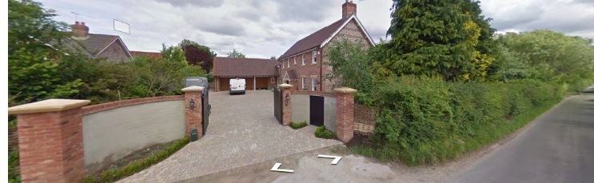

After:


